SERVICE BULLETIN

DATE: 04/30/2026

SUBJ: TD600 Danfoss Receiver Relocation

Machine Model: TD600

Serial Numbers: 502867 and below

Action Requested: Immediate Inspection and Correction
Parts Required: None – Information Only
Issue Description:
Few earlier model TD600 had issues with the Danfoss receiver being mounted flat in floor in the front access panel, this caused problems for the receiver when water made its way into the access panel.

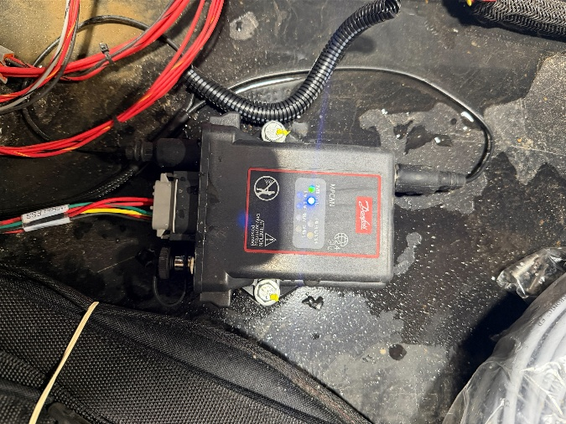

Fix: Relocating receiver to the inner side of the access panel.

  - First you will need to drill 2 holes. You will first measure distance from the bottom screw off your electrical connector out in inches look at image down below for reference, mark with paint pen then drill both holes.
  - 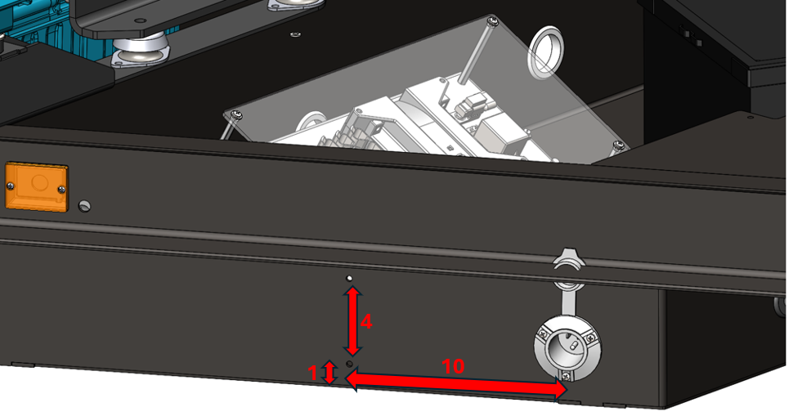
- New receiver holes drilled
- 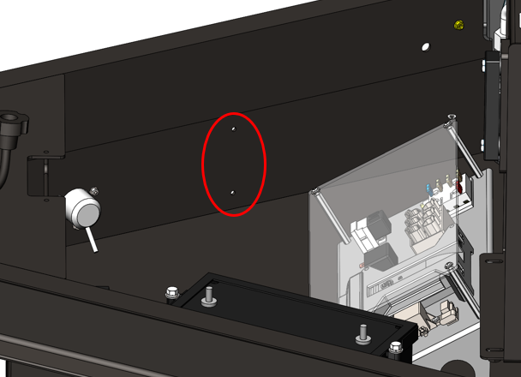

  - Once both holes are drilled you will remove both bolts and nuts holding down receiver to platform, then move receiver to the left side and mount receiver sideways on wall. Re-install bolts and nuts.
  - 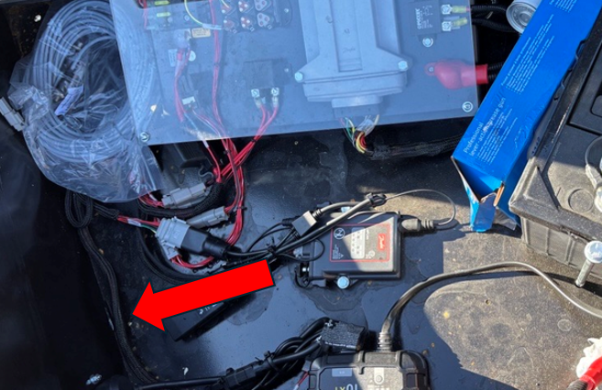

- Finished product should look like image below.

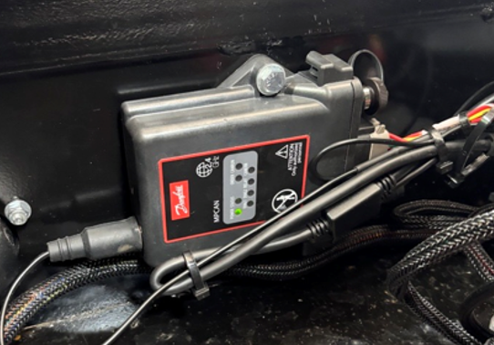

LeeBoy will warrant 2 hours of labor for the repair and $150.00 for travel .

Please file regular machine warranty.

For questions or concerns, please contact Rapid Response at 844-205-5499, or by email at support@leeboy.zendesk.com

